Crime-Free Leasing
Partnering Fort Collins Police Services, City of Fort Collins Housing, Property Management, and Residents
Location: Fort Collins, Colorado, United States
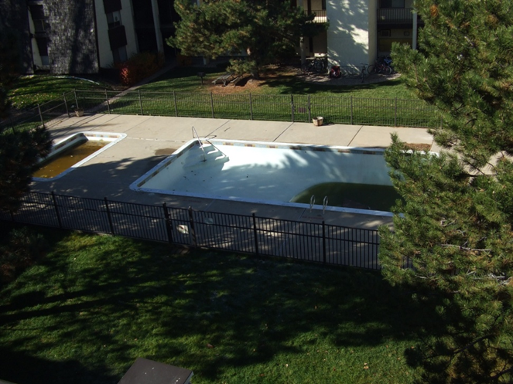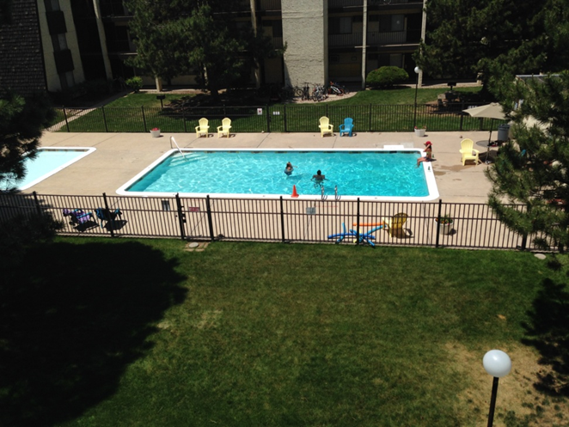
Project Contact Person
Name- Laura Knudsen
Position- Neighborhood Enforcement Team (NET) Police Officer
Address – 2221 S Timberline Rd, Fort Collins, Colorado, US
Phone – 970-222-2497
Fax – 970-416-2980
Email – lknudsen@fcgov.com
Key Project Team Members
Officer Annie Hill
Officer Josh Goldschmidt
Officer Chip Avinger
Fort Collins Housing Authority
City of Fort Collins Neighborhood Services and Code Compliance
Section 1: Summary
There were several multi-family dwellings throughout Fort Collins that posed a drain on police resources and decreased the quality of life for citizens in the surrounding areas because of the chronic criminal activity coming from them. The criminal activity ranged in severity, but most of it stemmed from the same people or units. Property managers, patrol officers, and neighbors quickly became frustrated because these individuals remained at these locations exhibiting the same behaviors. Neighborhood Enforcement Team (NET) officers saw this issue as a priority and worked on simple, effective solutions to reduce the calls for service coming from these areas. Our team agreed to start working with the three complexes producing the highest call load from the previous year (2012) – Bull Run Apartments, Buffalo Run Apartments, and Whispering Pines Apartments.
Initially, NET area officers set up meetings with the property managers at these locations to open up dialogue about the individuals who engaged in chronic criminal activity on their properties. Additionally, property managers shared the lease contracts with NET officers, carefully combing through the lease’s specific details. After a closer look at the lease, a section noted “Crime-Free Addendum” became the focal point. The Crime-Free Addendum is a contract between landlord and tenant whereby the applicant agrees prior to tenancy to abide by the rules of the property and not to participate in criminal activity while on-site. This lease addendum allows managers to evict residents based on criminal activity that residents engaged in while on the property. Specifically assigned NET officers worked with the managers at these 3 properties to communicate information about criminal activity.
As a result of the implementation of crime-free leasing, the call load has decreased significantly at all three of these properties.
- From 2012 to 2014, calls for service showed significant reductions at all 3 properties - Bull Run Apartments experienced a 25% reduction, Buffalo Run a 40% reduction, and Whispering Pines an 88% reduction.
- The quality of life for the citizens living at these locations has increased in contrast. Multiple residents have reported feeling consistently safer in their neighborhood. Although police officers typically have taken calls in these areas seriously in the past, the lack of consequences made neighboring citizens believe nothing was being done. The new partnership between property managers and law enforcement created a sense of empowerment for these residents.

Section 2: Description
Scanning
In the year 2011, The Fort Collins Police patrol division noticed they were frequently responding to select apartment complexes in the City of Fort Collins. In comparison to other parts of the city, these complexes’ calls for service were significantly higher than other parts of the city. The responses to these calls generally required multiple officers due to the types of calls and the overall environment and culture of the complex itself. A majority of the contact between police and the tenants were related to criminal issues. This created a very anti-police community. These apartment complexes were run down with trash in the courtyards, moldy interiors, cockroach and bedbug infestations, and diminished structures. The aesthetic issues were noticed by community members and neighboring multi-family dwellings as well as police officers working these areas. This suggested there was no real investment by anyone to these complexes, which created breeding grounds for further criminal activity. Drug dealings began occurring in and around the complex, which became apparent and problematic for neighboring complexes who noticed unwelcomed persons parking and walking in their parking lot and throughout their complex. Unwanted persons began engaging in further criminal activity including burglaries and vehicle trespasses.

These complexes were brought to the attention of the Fort Collins Police Neighborhood Enforcement Team (NET) by patrol officers and citizens living in those surrounding communities. NET Officers responsible for crime trends in those areas worked with crime analysts to pull data on calls for service for specified apartment complexes and multi-family dwellings. Based on data, it was determined officers were responding to calls at these locations almost daily, sometimes multiple times a day. Amongst these calls, patrol was consistently responding to repeat units.

NET Officers took a closer look at the tenant populations of these complexes. Nearly 20% of the populations were receiving subsidies from either the City of Fort Collins (Fort Collins Housing Authority) or some other type of non-government organization (Veteran’s Assistance, Touchstone Mental Health Parnters, etc). Several of these subsidy holders were deemed to be part of the problem. Although officers were issuing citations and arresting when appropriate, the tenants were remaining on the property with expenses paid by someone other than themselves. NET conducted follow-up when officers responded to these calls. Often times, other individuals not on a lease were found to be staying with the (subsidy holding) tenant. The tenant’s guests were also part of the problem. The guests, sometimes known as “couch surfers”, would stay at the complex for a few days at a time. This was within the lease guidelines. Management and service providers were often unaware any problems were occurring at those apartments, were unable to identify these problematic guests “couch surfers”, and/ or felt their hands were tied. The rent and utilities were generally paid in full and on time. Management did not feel they had grounds for eviction or taking any type of action against the tenant. The agency governing the tenant’s subsidies were in the same predicament and were usually unaware any criminal activity was occurring. These outside agencies were also not informed of the living conditions at the complex. Because of the anti-police/government culture within the complex, citizens did not speak up about undesirable living conditions and did not see police as a resolution or a voice to their problems.
When the scope of this problem was looked into, it was apparent the tenants of these problematic complexes needed enforced guidelines to encourage law abiding behavior as well as a developed investment to their community.

Analysis
Through the observation of patrol officers and the Neighborhood Enforcement Team, 3 low income federally funded apartment complexes were identified as high resource/high crime locations within the City of Fort Collins. These 3 apartments were then targeted and data was pulled to find out what percentage of patrol officers time and resources were being used to respond to calls for service. A Fort Collins Police Services crime data analyst confirmed the observations of patrol officers with data gathered from police data bases.

High crime and calls for service had persisted for many years prior to 2011. Methods used to battle the problem areas involved assigning proactive patrol officers to the areas and directed patrols. This response to the problem did not have a noticeably positive effect. Along with no reduction in call load/crime rate, no real relationships had been developed between the apartment management offices, residents, and Fort Collins Police Services. This resulted in a much broader problem than just high call load for Fort Collins Police Services. This created a quality of life issue for the residents as well.

The Neighborhood Enforcement Team went into these apartment complexes and built relationships with both the residents and the employees of the apartment management team. Through individual and community meetings everybody was educated about the problem of high criminal activity. With the use of a Crime Free Lease, Fort Collins Police Services and the managers of the complexes were able to communicate about criminal activity involving residents of the complexes. The Crime Free Lease Addendum gave the apartment managers the ability to hold their tenants accountable for their actions. The most beneficial resource used in conjunction with the Crime Free Lease was the Ops Force Corona Solutions support. Fort Collins Police Services data analyst gave each apartment manager an individual alert when a call was entered at their respectable locations. This was a tool to allow the manager to respond accordingly in a reasonable time frame on criminal activity when a violation of the Crime Free Lease had occurred. In return this fueled the management’s relationship with NET officers and increased forward thinking ideas and action plans from both sides.

Response
The areas that NET targeted as part of this project were selected because of the consistently high number of police calls for service at these locations. We considered proactive enforcement of criminal law violations using highly visible presence by uniformed officers in marked police vehicles. We also considered surveillance, by plain-clothes officers in unmarked vehicles, of specific rental units where criminal activity was suspected. The surveillance would lead to subject stops of suspected participants. We also felt there was a need to actively involve the city’s code enforcement to address code infractions for targeted properties.

Initially we used all of the tactics mentioned in the previous paragraph to address the targeted properties. During this process we learned the problem was systemic in nature. Treating the symptoms only alleviated the problem for a short period of time. To have a long lasting impact on the targeted apartment complexes we needed a partnership with the apartment/housing complex managers and in some cases the property owners, in a coordinated effort.

We had to affect who was being allowed to live in these rental units. What was needed was a complete change in what were acceptable norms for tenants of these apartment complexes. There needed to be an understanding within these communities that criminal activity on the premises would result in eviction.

Our primary goals were to create long-term solutions to ongoing or habitual problems which were criminal in nature, to reduce the number of police calls-for-service, and to also improve the quality of life for the citizens within these communities.

We understood that even within some of our most problematic housing complexes there were citizens that were not involved in criminal activity and do not live by criminal means. These citizens typically feared the problematic residents and their quality of life suffered because of the criminal element that surrounded them.

We intended to remove the criminal elements from these housing complexes and completely change the culture. By removing the individuals that were living by criminal means we would reduce the police calls for service and create a safer and more enjoyable place to live for the tenants as well as the surrounding community.

We used a variety of resources while implementing our response plan. Depending on what type of suspected criminal activity was taking place we used plain clothes officers in unmarked cars or other apartments within the complex for surveillance or vehicle follows. We also used uniformed officers in marked patrol vehicles for stops or take-downs, cameras, a Tracfone cellular phone, bait equipment, property trackers and vehicle trackers, and faux social network pages to gather intel on problematic residents.

The response to this issue was multi-faceted. First, we needed to make our city’s code enforcement and compliance office aware of our impending efforts and bring them in to assist when practical and/or necessary. Then we needed to develop relationships and rapport with apartment complex managers and property owners. We also needed to spend time educating the property managers. Most of them were aware that their leases contained a crime-free portion, but they were unsure of how to effectively utilize it. They needed to know that if they brought a problem tenant to our attention that we would respond and use the best tool for the job to develop criminal charges against the tenant. Once criminal charges were obtained, the managers would have the capability to evict those tenants. The partnership between those managers/owners and our police unit would have a dramatic effect on their apartment complexes.

We faced a few obstacles during implementation of this project. One obstacle was the educational process for the apartment managers and the coordination between our policing unit and our city’s code enforcement and compliance office. After several meetings and informational sessions, we made great progress with bringing the multiple sectors together. We still had one of the owners of a large, crime-ridden apartment complex who was initially unwilling to participate with this effort. This was a complex that already had a crime-free addendum in its lease; however, there was significant resistance to applying it to evict people. After code enforcement sanctioned the apartment complex and parts of the complex were facing possible condemning due to health concerns, the owner reluctantly decided that he should start evicting major offenders and making some repairs to neglected areas of the structure.

Assessment
The criminal activity at these 3 multi-family dwellings has been an issue for years. For the purpose of consolidating the data in this assessment, we focused on the time period 2011-2014. Fort Collins Police Services crime analysts ran police calls in our system for the years 2011-2014. Specific calls that we eliminated from the analysis were officer-initiated activity like directed patrol and extra patrol as well as traffic-related calls.
The partnership between property management and law enforcement needs to remain long-term in order for these properties to continue to gain significant improvements and maintain a good reputation.

Bull Run and Buffalo Run Apartments are managed by the same company. The demographics at these multi-family dwellings are similar; both participate in Section 8 Housing. The following graphs show the data compiled by our crime analyst. The calls for service are shown on the vertical y-axis and the quarterly time period is depicted on the horizontal x-axis. It is important to note that the substantial decline in calls for service is likely due to the increased communication between property management and law enforcement. The results for 2011-2014 are as follows:

Graph 1.0

*Shows a significant decrease in calls for service from 2011 to 2014

A major goal of NET is to reduce the call load for patrol officers at FCPS. Between the years 2013-2014, Crime-Free Leasing was well-established at these properties. Property Managers were comfortable communicating with NET officers regarding on-site criminal activity and with the procedure of evicting a tenant as recourse.

From 2012 to 2014, the data shows Buffalo Run Apartments showed an approximately 40% reduction, and Bull Run Apartments showed an approximately 25% reduction. This was a significant decrease in the calls for service for patrol officers and an equally obvious increase in quality of life for residents at these apartment complexes.

We have separated the data from Whispering Pines simply because Buffalo Run and Bull Run Apartments had the same management company. Whispering Pines operated independently from the other two complexes. It’s important to keep in mind that crime-free leasing will be affected by the diligence of not only police officers, but also property management. In the graph below, there was a noteworthy dip in calls for service in the year 2014 from Quarter 1 to Quarter 4 at Whispering Pines. This was a result of crime-free leasing being established as well as a management turnover during the year.
Graph 2.0
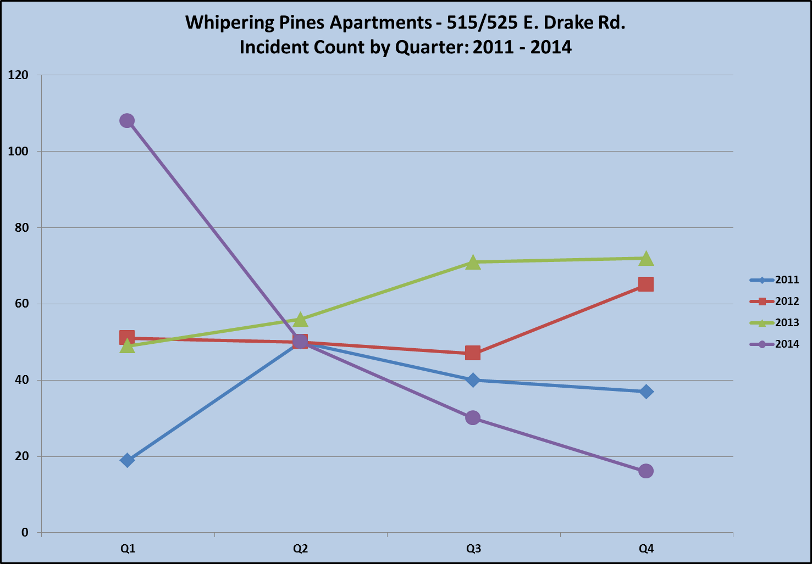

The implementation of crime-free leasing was a partnership between the Fort Collins Police Neighborhood Enforcement Team, the City of Fort Collins Code Enforcement, and a multitude of property managers and owners. Based on the data, the method we used to resolve this ongoing issue was effective and the results showed our goals were met. Fort Collins Police Services will continue to implement Crime-Free Leasing as a routine protocol.

