2013 Herman Goldstein Award submission

GANGS: Tackling a neighbourhood gang occupation at ‘Gun Alley’ Bermuda.
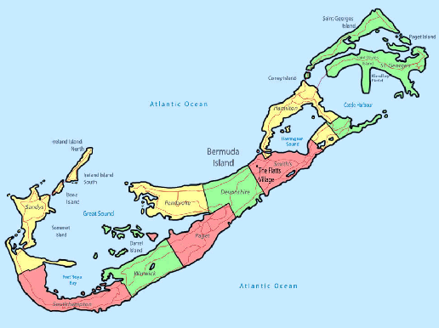

Agency and Officer Information:

Submitting Agency: Bermuda Police Service
Project Contact Person: Paul Wright
Position: Assistant Commissioner of Police
Address: Bermuda Police Service
#10 Headquarters Hill,
Prospect
Devonshire
Phone: (441) – 247 – 1281
Email pwright@bps.bm

Key Project Team Players
Phillip Barnett (Cambridge Road CAG)
Ryan Dumoulin (Cambridge Road CAG)
Dawn Simmons (Sandys Parish Council)
Michael Scott JP MP (Cambridge Road elected Member of Parliament)
Robert Cardwell (BPS Western Area Commander – Project Leader)
Valerius Jean-Louis (BPS WCAT)
Cerepha Bridgeman (BPS WCAT)

Summary
Scanning:
Between 2009 and 2012 gang-related gun crime increased exponentially in Bermuda. Although crime levels were at historical lows, the increased gang activity created a fear of crime that was disproportionate to the reality and some gangs took root within neighbourhoods where they brazenly harassed and intimidated local residents. Local gang “Money over Bitches” occupied the area of Cambridge Road and re-named it: Gun Alley. Increased gang activity had a negative impact on public confidence in the Bermuda Police Service (BPS) which in turn contributed to a general island-wide increase in the fear of violent crime.
Analysis:
Public Perception Surveys showed the increased fear of crime was directly related to the proliferation of gang activity. The data revealed that the public wanted the BPS to be more ‘visible’ and that many people stood ready to play their part, including working as members of Community Action Groups (CAG). Crime data and gang intelligence assisted in establishing Cambridge Road as a priority. The Problem Analysis Triangle was used to identify the environmental and human factors involved. Anti-social behaviour consistent with the theories of ‘Rational Choice’, ‘Routine Activity’ and ‘Broken Windows’ were identified.
Response:
A Problem-Oriented Policing (POP) initiative was established to tackle the gang occupation. Local stakeholders and embedded potential capable guardians were identified and broad community consultation yielded support and understanding for the initiative and also for one of the more potentially controversial enforcement options; the use of anti-loitering/congregation powers for the first time. Maintaining a balanced community policing ethos combined with enforcement of legislation was a key to success. The response took into account the contributing environmental variables of the specific problems being experienced by this particular neighbourhood. Over a period of six weeks the CAG and the BPS worked together to clear and rehabilitate the area and to restore the Cambridge Road community to its pre-gang occupation status.
Assessment:
The initiative removed the gang occupation, reduced crime and led to an increase in public confidence and a reduction in the fear of crime. It is significant that the effort made in the community consultation phase included the gang itself. As a result, although arrests for various offences increased during the initiative, there were no arrests for loitering/congregation offences and no complaints against police. The capable guardians of the CAG continue to work with the BPS and guard against a return to the old Gun Alley days.

GANGS: Tackling a neighbourhood gang occupation at ‘Gun Alley’ Bermuda
Background
The islands of Bermuda are a British Overseas Territory situated six hundred miles off the coast of North Carolina. The main land mass comprises of seven islands that are seamlessly linked by causeways and bridges covering an area of 21 square miles with a population of 64,000 residents. Bermuda generates the majority of its revenue from tourism and financial services related to insurance and reinsurance markets. Bermuda is heavily reliant on these two industries and recognizes that both are influenced by the level of confidence that Bermuda is safe to visit and an appropriate place to conduct business.
In 2006 the Bermuda Police Service (BPS) made recommendations for legislation to help combat emerging gang activity and anti-social behaviour but the problem became more deeply-rooted and deadly between 2009 and 2012. The proliferation of gun crime directly or indirectly affected many Bermudian families and other local residents due to their close proximity to the crimes – both geographically and culturally through their extended families. The proximity to the crimes coupled with the speed of the escalation eroded public confidence and therefore the very life blood of the economy of Bermuda. In the years between 2005 and 2008 nine people were shot, three of whom died from their injuries. Appendix A shows that during the next three years between 2009 and 2012 the number increased to eighty persons shot, of whom twenty-one died from their injuries.
The annual Bermuda Police Public Perception Survey shows that since 2009 there has been a steady rise in the ‘fear of crime’, particularly the fear of violent and gang related crime at the neighbourhood level. The fear of crime is disproportionate to the reality, which is that most other classifications of crime are at the lowest levels in twelve years. The same survey reveals a marked increase in public interest to get involved in Community Action Group (CAG) work in partnership with the BPS.
Gangs in Bermuda are involved in the sale and supply of illicit drugs. Gang member’s guard their ‘turf’ and the members band together for protection from rival gangs from other neighbourhoods. Residents of some neighbourhoods occupied by gangs say they ‘live in fear’. This fear is the result of intimidation and harassment by men who loiter in locations that cannot be avoided by residents as they leave and return to their homes every day. It is also common that many of those gang members do not reside within the neighbourhood they occupy for illicit purpose.
The problems suffered were exacerbated by a lack of cohesion between politicians, the BPS and the local area residents as to who was responsible for the challenges Bermuda faced with gangs and the related proliferation of gun crime and other gang activity. The BPS response plan to the problem was multi-faceted and included the development of a Gang and Violence Reduction Strategy (GVRS). The GVRS was based on a hybrid of the Boston Gun Project (Kennedy, Braga and Piehl, 1995) and the Birmingham Reducing Gang Violence Strategy (Safer Birmingham Partnership, 2010). Within the parameters of the Bermuda GVRS broad tactics were deployed within neighbourhoods suffering from gang occupation. These tactics included intelligence-led and high-visibility police deployments to provide reassurance to law abiding citizens and disrupt both planned and spontaneous gang-on-gang attacks. Disruption was caused through enforcement and the exercise of all lawful powers within the affected neighbourhoods. However, in spite of enhanced enforcement activity gang members continued to congregate and use neighbourhoods as a hub for their criminal activity. It was accepted that the BPS could not remain in every affected neighbourhood for every hour of the day and arrest it’s away to a permanent solution. The assistance and support of local residents was needed.
The BPS approach provided reassurance to law abiding members of the communities and some disruption of gang associated violent crime, but it did not provide an enduring solution to the problem by eliminating the ‘bad behaviours’ of individuals. Each of the neighbourhoods occupied by gangs has different environmental and other variables that make it easier for gangs to remain there. The police needed specific and increased enforcement powers to force gangs to increase the effort to remain. These powers were provided for under new, but potentially controversial anti-loitering legislation under a Criminal Code Amendment Act.
It was also apparent that a problem-oriented approach needed to be taken if longer term, more sustainable solutions were to be found. Using the theories of Routine Activity and Rational Choice the solutions lay firmly in identifying capable guardians by partnering with affected stakeholders. These partnerships included the Government of Bermuda for enhanced legislation, the BPS for enforcement, stakeholders at the community level for influence and the residents of the affected neighbourhoods.
The success of the Cambridge Road POP initiative was the result of a systematic approach that resulted in an effective bespoke response that was appropriate to address the specific features of the problems confronting that neighbourhood. That response included the use of potentially controversial anti-loitering legislation for the first time in a manner that was proportionate and ultimately supported by the residents and understood by the gang members.

Scanning:
Cambridge Road is located at the west end of the island in the village of Somerset in Sandys Parish. A single road connects Somerset to the rest of the island, leaving the area somewhat isolated in comparison to some of the other neighbourhoods in the island suffering from gang occupation and related crime. The residents of this neighbourhood were suffering from the ‘fear of crime’ as a result of an occupation by gang whose members who congregated at the eastern entrance to the Cambridge Road neighbourhood. Members of the gang are well known locally to be suspected in numerous shootings and the sale and distribution of illicit drugs and other criminal activity. This gang branded themselves as M.O.B. which is an acronym for ‘Money Over Bitches’. Intelligence sources and other linked data confirm that this gang has a firm control over criminal enterprises in the western end of the island and rules through intimidation, harassment and fear.
Cambridge Road, Sandys Parish is a through road consisting of two access points at its west and east ends. The most convenient entrance is its eastern access which is off the heavily travelled main road. A small bar is located at the junction of Somerset and Cambridge Roads and immediately opposite there is a four-dwelling condominium complex. Next to the bar there are two lots of undeveloped land that have not been developed and are overgrown by shrubbery. It is in this location that members of ‘M.O.B.’ congregate and loiter. No person was taking ownership of one of the two lots of undeveloped land as a consequence of a family dispute over ownership. The second lot of land immediately joins it and the owner had declined to maintain it as a result of the first lot not being maintained. There was a network of foot-trodden pathways across the two lots which were obscured by dense vegetation. Beyond the two vacant lots lies a middle-class neighbourhood with well-maintained houses lining both sides of the road. Cambridge Road is also an access road to the Cambridge Beaches Hotel which is a retreat for high net worth visitors to the island.
The problems associated to the M.O.B. occupation had been a reoccurring problem for the neighbourhood and the police for approximately ten years. However, since 2009 there has been increased gang activity and these men openly marketing themselves as hard-core gang members and taking the gang name ‘Money Over Bitches’. Fear and intimidation was very much on the rise. The name ‘Cambridge Road’ was renamed by the gang and referred to as ‘Gun Alley’. In fact ‘Gun Alley’ became the colloquial name for Cambridge Road and this was the name most used to describe the area even by ordinary members of the public. Historically, most of the calls to the BPS for service were to deal with complaints associated to noise, drug consumption and sales, public consumption of alcohol and intoxication, blocking the road, speeding motorcycles through the neighbourhood and the use of profanity and threats to area residents.
Over the years the BPS responded to this area to deal with the offences that were reported. The usual response by the police was to exercise powers of search for illicit drugs on individuals, using drug sniffing dogs for area searches, arresting individuals on outstanding warrants and confiscating alcohol - all of which provided temporary disruptions to illicit gang activities. Many of the other offences required evidence from named complainants unless those specific offences were observed by police. Typically area residents would not follow through with complaints as a consequence of the fear they suffered.
The owner of the bar at the entrance to Cambridge Road attributed lost business to the gang occupation almost at the doorstep to her establishment. Although M.O.B. gang members made purchases at the bar, the majority of business had been generated from other area residents, who were now too fearful to patronize the bar.
The management team at the exclusive Cambridge Beaches Hotel was also concerned about the impact of the gang occupation on their guests. The hotel had taken to steps to advise their visitors to avoid the eastern entrance of Cambridge Road and use the western entrance instead. The same precaution was also adopted by taxis when transporting visitors to the hotel.
Community policing using a problem-oriented approach is a priority for the BPS that is explicit in its Policing Strategy and Annual Plan. However, it was not always so. Historically the BPS approach was to indiscriminately target youths in ‘troubled neighbourhoods’ and this had led to a lack of community support generally. The BPS invested time into the building of trust and relationships to counter gun crime and assist investigations. Members of the BPS Western Community Action Team (WCAT) had been deployed within the neighbourhood and built individual relationships with members of the Cambridge Road community. However, as a consequence of the problems being in existence for such a long period of time and the perceived inability of the BPS to resolve the problem in that time, there was a general feeling of hopelessness.
In 2010 the Bermuda Legislature enacted an anti-loitering law that empowered the police to make declare that it would be unlawful for persons to congregate in specific public areas for fixed periods of time but this authority would not exceed six weeks. The process to designate such an area involved issuing a public notice that provided details of the area and the time period this power would be used. The BPS had not previously used the power and appreciated the potential controversy that might result for some arising from concerns about the constitutionality of the action. The BPS was also concerned that the use of such a power might be perceived by some as running counter to the ethos of the prevailing community policing approach that had already made such a positive impact on its ability to investigate serious crime. It is fair to say that the BPS viewed the use of the new power as an option of last resort that would require strong community support.

Analysis:
Specific analysis of the reoccurring problems being suffered by the Cambridge Road neighbourhood were directly related to the ‘M.O.B.’ occupation, their reputation and the limitations of police powers to deal with the problem and the absence of a planned coordinated and sustainable solution.
The established police approach to the problem was essentially a one-sided reactive response that was ineffective. The relief that the police response provided for the residents was temporary, did not resolve the problem and did nothing to enhance public confidence in the BPS. The ineffectiveness of the BPS response emboldened some of the gang members, reinforcing their perception that they were untouchable and at liberty to continue to intimidate residents after the police had left. The persistence of the problem and looking at the problem through a narrow scope highlighted that the problem had been further aggravated by neighbourhood frustration and their general lack of confidence in and a lack of support of the BPS as a result of a decrease in the quality of life suffered and an increase in the fear of crime. The aforementioned geographical and cultural proximity of the M.O.B. gang to the rest of Bermuda created a ‘signal crime’ effect (Innes and Fielding, 2004) resulting in the local impact of the gang activity at ‘Gun Alley’ influencing the disproportionate fear of crime to the wider Bermuda community.
The working hypothesis to the problem was that the location was well-suited to provide an ideal environment for motivated offenders within the gang to conduct their illicit activities with a degree of impunity. The police could not approach undetected. The lots were very densely overgrown, providing cover, concealment sites for weapons and drugs and a choice of escape paths. There was no effective ownership of the two lots and the residents were not motivated to act as capable guardians. From the perspective of the offenders, the benefits of the location outweighed the risks and they became comfortable at that location to the point where they erected shelters to protect themselves from the elements and set up home comforts that included couches, recliner chairs, barbeques and tables.

Response:
Anti-loitering legislation that had never been used before in which the police would be able to exercise dispersal powers effectively in response to the congregation of M.O.B. members needed to be used in concert with other remedies to the problem. It was critical that these powers be exercised in agreement with the occupants of the Cambridge Road neighbourhood together with the support and understanding of the wider Bermuda community and local politicians. This would require an effective media strategy and extensive stakeholder consultation to direct attention to the problem being suffered on Cambridge Road and accomplish a general understanding of what the police sought to achieve by exercising the powers under the legislation and why it was proportionate to exercise the power.
The Western Area Police Commander and his CAT Officers identified stakeholders associated with the Cambridge Road problem. These included area residents, the Sandys Parish Council, the local area Member of Parliament, the holders of the two lots of undeveloped land, the owner of the bar, the manager of the Cambridge Beaches Hotel and the BPS. Members of the BPS Western Area Community Action Team (WCAT) visited with all stakeholders and a meeting venue and date was agreed.
At the meeting, an analysis of the problem being suffered was presented in a narrow scope from both a police and neighbourhood perspective. The attendees of the meeting galvanized and formed a Community Action Group (CAG) and together they brainstormed and discussed solutions to the problem.
The challenges of creating a sustainable solution were discussed and it was agreed that residents of the Cambridge Road neighbourhood needed to assume the role of capable guardians and work together to resolve the problem. Critical success factors were agreed including the need for regular CAG and BPS meetings, the need to eliminate the environmental factors that helped facilitate the gang occupation, the creation of an active Neighbourhood Watch Group and for the BPS to exercise in concert with these measures new anti-loitering powers to disrupt the anti-social behaviours.
Working together over a period of two weeks, the CAG and the BPS developed plans to put in place the appropriate prevention mechanisms to neutralize the perennial neighbourhood problems outlined from the perspective of Rational Choice
The response plan included:
- A joint press conference was held in which members of the CAG and the BPS were represented. The press conference was used as a publicity mechanism to raise the public awareness and understanding of the scope of the problem suffered by the Cambridge Road neighbourhood. This also helped prepare and gather support for the use of anti-loitering police powers that would be exercised and why exercise of these powers was proportionate to the problem. The consequences for non-compliance were explained and what it hoped to achieve not only for the Cambridge Road neighbourhood but also the benefits for the wider Bermuda community.

- The BPS caused public notice of its intent to exercise anti-loitering powers of enforcement, the area and duration this power would be exercised in the media and that these powers would be enforced for the maximum permitted time (See Appendix B).

- The BPS met with gang members to explain how the BPS was going to use the mechanism of increasing the risk for them during the enforcement phase of the initiative. Leading members of M.O.B. were advised that their bad behaviour would no longer be tolerated and that loitering on Cambridge Road was not permitted. There were no excuses for non-compliance and the consequences included a heavy monetary fine and/or imprisonment for failing to comply were explained. The gang understood the extra effort that they would need to make to continue to gather at that location and the increased risks to them for doing so and they immediately vacated the area.

- In agreement with the owners of the two lots of undeveloped land and with their participation the Cambridge Road CAG set a date in which the two lots of land were cleared. The CAG supported by members of the WCAT cleared the two lots of land of all overgrown shrubbery, make-shift wooden shelters, furniture and other comforts of home items that the gang had installed. Local area landscapers and a construction company responded to the plight of the Cambridge Road neighbourhood and volunteered equipment, machinery, trucks and operators to assist in the clean-up. The clearing of the lots amounted to crime prevention through environmental design (CPTED) by removing or changing the environmental factors that had enabled the gang occupation.

Assessment:
The initiative was a big success. The BPS, the CAG and the other stakeholders all worked together to make rational choices to target specific aspects of the problem. The combination of the police enforcement action and the CPTED actions taken were a critical success factor in preventing the problem reoccurring since the end of the enforcement phase. Perhaps more important is the continuing resolve of the CAG to continue to work together as capable guardians and to maintain lines of communication with the BPS. Not only has the appearance of the neighbourhood been improved, but the quality of life for the area residents has improved. The gang has vacated the area and any reference to the area ‘Gun Alley’ has all but ceased. The eastern area of Cambridge Road is now once again commonly used by foot and vehicular traffic without any obstruction, harassment or intimidation.
The owner of the bar at the entrance to the Cambridge Road reports a steady improvement in business thanks to a change of clientele now frequenting her establishment and the elimination of the hostile environment that once had a firm grim of the area. Cambridge Beaches Hotel no longer advises their visitors to avoid the area.
The publicity that the initiative attracted assisted in extending the benefit of improved public confidence beyond the confines of Cambridge Road. Appendix C shows results from The Bermuda Omnibus Survey of 400 Bermuda residents. The survey reveals a sharp rise in public confidence after the start of the initiative among those who were ‘completely satisfied’ with the BPS. The improvement in public satisfaction has been positively influenced by the increased ‘visibility’ of the BPS which was achieved through a combination of the initiative, high visibility policing and an effective CAG and BPS media strategy prior to commencing the initiative and also afterwards to publicise the successes.
Data linked to the effective ‘visibility’ of the BPS was also highlighted when measuring BPS performance in the six week period prior to commencing the initiative, during the initiative and after the initiative. Appendix D shows a decrease in crime during the initiative. This can be attributed to the increased police presence in the area, the community intelligence generated by the CAG and of M.O.B.
The empowerment of the CAG led to a much-improved flow of information to the BPS and less tolerance for any crime which in turn resulted in an increase in the volume of crime reported. This is directly attributable to the increased community confidence. Appendix B also shows that there was a marked increase in the number of arrests during and after the initiative in comparison to the six week period prior to the initiative commencing. The sharp increase in arrests can be associated to the increased visibility of police in the area, increased community patrols and the subsequent displacement and disorganization of M.O.B. that occurred due to the sharpened on-going focus on targeting their bad behaviour.
In the on-going BPS monitoring of the area it was discovered that the M.O.B. gang moved in smaller groups to other locations as a result of the initiative. However, it is important to state that the old problem was not displaced from Cambridge Road. The gang moved to another nearby location away from any public thoroughfare but without reoccurrence of the old behaviours that led to the initiative against them in the first place. The disorganization of M.O.B. is reflected in the reduction of firearm crime in the area.
It is noteworthy that communicating the relevant prevention mechanisms to the gang members in advance appears to have had the desired effect in that during the course of the initiative there were no arrests for failing to disperse. It is also significant that there were also no complaints made against police. The communication with the gang made it clear that the focus of all police action was targeted against poor behaviour alone. To date, the gang appears to have avoided re-attracting the attention of the police and area residents
Appendix E shows from Quarter 3 (Q3) of 2012 when the Cambridge Road initiative concluded to the present, there is a downward trend of firearm related crime which is directly related to continued assessment of the initiative and the on-going continue focused targeting of the bad behaviours of M.O.B. members and taking advantage of their disorganization.
The success of the initiative prompted other community leader to reach out to the BPS and request similar actions to address problems in their neighbourhoods. The police use of dispersal powers together with the elimination of contributing environmental factors using the ‘Fixing Broken Windows’ theory (Kelling and Coles, 1996) have been hailed a success and there is much wider recognition of POP and Community Policing both within the BPS and also the wider community.
On-going consultation with the Cambridge Road CAG at regular meetings and feedback through the media also highlight the success and improved quality of life experienced as a result of this POPP initiative. Public responses published in print media include:
- “I have peace and quiet for the first time in ten years outside of my home”.
- “I have definitely noticed a difference, I just hope it lasts.”
- One business has reported “Patrons who were staying away from the premises have returned, reporting that they feel more comfortable to do so”.
Conclusion
This pathfinder pilot project to tackle the gang occupation of a neighbourhood and the associated bad behaviour using a Problem Oriented Policing and Partnership approach had a number of positive benefits for the neighbourhood suffering from the problem, the wider community and the BPS. The occupation of ‘Gun Alley’, Bermuda by the Money over Bitches gang was eliminated and the success can be linked to an increase in public confidence. The approach that occurred using the framework of the Problem Analysis Triangle and the planning that followed together with the publicity linked to this initiative made this project a model for other neighbourhoods to follow.

Appendix A – Graph showing Firearms Fatalities and Injuries in Bermuda
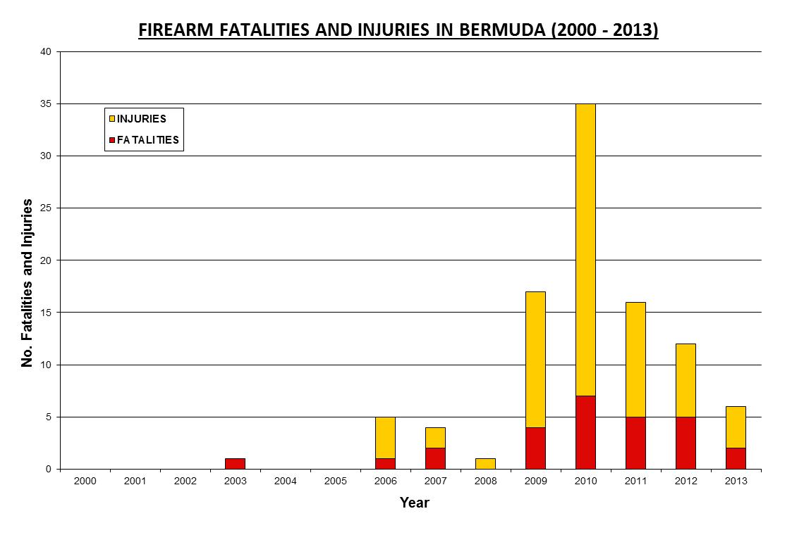

Appendix B – Notice to the public.
NOTICE OF AN AUTHORISATION TO DISPERSE GROUPS
Section 110B of the Criminal Code Act 1907

Notice is given that:
Name of Officer | Robert W. Cardwell
Rank | Acting Chief Inspector
of the Bermuda Police Service, has made a written authorization under
Section 110A(2 ) of the Criminal Code Act 1907.
Name of Locality | Sandy’s Parish
This authorisation will cover the following area within the locality of:

Namely,
Somerset Road between Broome Street and Cambridge Road, Cambridge Road and every public place contiguous to these roads.
and will commence:
0800hrs Thursday, 31st May, 2012
and will remain in force until
2359hrs Wednesday, 13th June, 2012
During this authorisation period the powers conferred on police officers under
Sections 110A(6) and 110A(8)of the Criminal Code Act 1907 in the area
specified above will be exercisable.

Appendix C – Chart showing the level of public satisfaction with the BPS
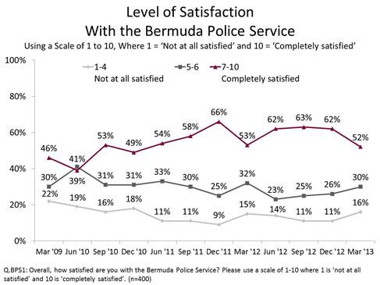

Appendix D – Chart showing the number of crimes and arrests in Cambridge Road, Sandys Parish six weeks before, during and after the initiative.

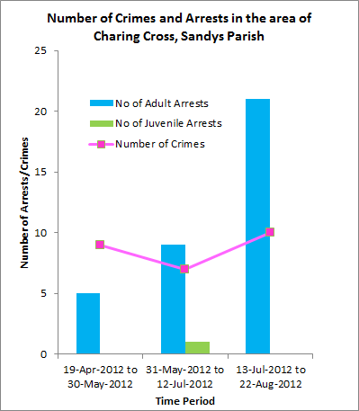

Appendix E – Chart showing Firearm Incidents in Sandys Parish by Quarter
(2008 – 2013)
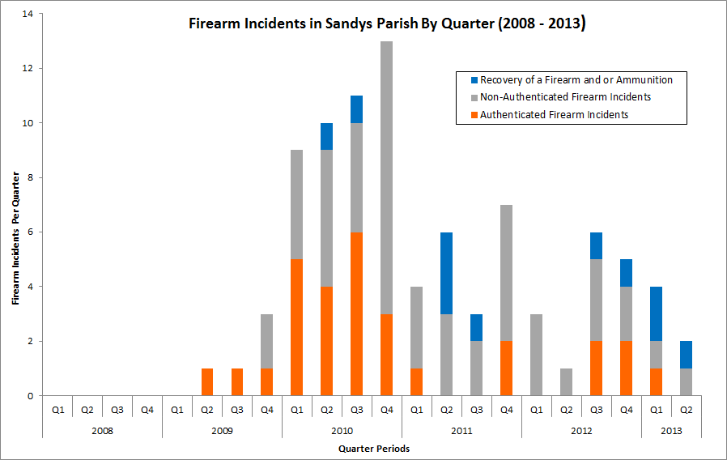

Photograph of the Cambrigde Road, CAG, WCAT and community stakeholder particpants in the clean-up.
