Project Name: The Woodhouse Village Regeneration Project
Location: Sheffield District - Summary:
Woodhouse is located in the South East of Sheffield and borders with Rotherham. The area is predominantly residential and previously consisted of smaller communities, but over time, has developed considerably as prosperity and the need for housing has seen influxes of housing stock and people into the area. The area is well served by public transport and the main shopping area, centred at Woodhouse Village, has a number of occupied retail units, including a Co-Op, eating establishments, a Doctors Surgery, the local Library and Council Housing Office.

From a South Yorkshire Police (SYP) perspective, the biggest challenge faced within Woodhouse is Anti-Social Behaviour (ASB); despite significant reductions over recent years, ASB still remains high and is a key concern to the community and partner agencies, particularly alcohol-fuelled ASB.
- Scanning was carried out from the very early stages of the project and included all key stakeholders including residents and elected members.
- Project’s aims had a clear link to the Government’s Alcohol Strategy.
- Analysis included interrogation of SYP incident system, ProCAD for ASB incidents and analysis of results from a perception survey carried out via a public consultation exercise.
- Response included enforcement (introduction of a Designated Public Place Order (DPPO), education / rehabilitation & regeneration of the identified area.
- A structures and robust evaluation was undertaken in each of the deliverable areas to ascertain its success. A continuous review process has proved vital to ensuring the success of the DPPO with perception surveys carried out routinely to assess the views of local residents and businesses.
- The project continues to add new initiatives to refresh the approach and ensure focus and flexibility.

No longer are residents subject to the behaviour of drunken adults; do businesses experience customers too frightened to shop and the persons responsible themselves no longer feeling that a sense of hope is almost futile. A whole community has come together to improve the lives of those affected and those responsible.
Word Count: 326
SCANNING
On April 1st 2011, the Woodhouse Designated Public Place Order (DPPO) launched to address alcohol fuelled ASB caused by adults within the community through enforcement, education and rehabilitation. Although launched in 2011, the project had been a culmination of partnership planning, working and discussion since 2009 when the Safer Neighbourhood Team (SNT) commenced preliminary research regarding the need and feasibility for a DPPO.

Historically, Woodhouse has experienced street drinking and associated ASB in and around the village centre, in particular Market Square. Between August 2008 and July 2009, the highest volume of recorded incidents (SYP ProCAD System) within the area was Rowdy and Inconsiderate Behaviour. 133 incidents of this nature were recorded, with Violence against the Person offences also a common feature with 33 incidents within the same period. Previous initiatives to tackle the problem only achieved short-term improvements. A series of “days of action” had increased visibility in 2009 resulting only in temporary reductions. It was evident that there was a localised need for the community itself, agencies and businesses to tackle drink fuelled ASB, related health issues and help individuals take control of and change their behaviour.

In late 2009, the Woodhouse SNT alongside an SYP Research Analyst completed a ‘walkabout’ within the Woodhouse area as a consultative process to consider options that could assist the local community, businesses and partner agencies address alcohol related problems. Consultation with key stakeholders also highlighted the impact this behaviour was having.

DEVELOPMENT OF PROJECT AIMS
SYP received considerable volumes of information reported via the 101 reporting facility as well as concerns raised through community meetings and correspondence. Despite significant reductions in ASB across the wider South East area, Woodhouse was seeing a disproportionate increase. The continuation of an increase in incidents would place high demand on limited resources and undermine the confidence of the community on the two organisations to address those issues of concern.

Sheffield City Council (SCC) - Safer Neighbourhood Officer acted as a conduit on behalf of SCC functions such as Street Cleaning, Parks and Countryside and StreetForce.

Residents and Community Groups - including The Neighbourhood Action Group(NAG), Woodhouse and District Community Forum, Salvation Army and two local Tenants and Residents Associations (TARAS) provided information directly from the community and acted as a conduit to building relationships between SYP and the community.

Public concern was highlighted when a discussion thread appeared on Sheffield Forum titled “Woodhouse really does need sorting out” with over 350 posts and thousands of views. http://www.sheffieldforum.co.uk/showthread.php?t=586890&highlight=woodhouse+needs . Letters were also sent directly to the SNT, requesting the issues be addressed (Appendix_1).

St Anne’s Bevin Court - resettlement hostel for homeless men aged 18+ who need support and temporary accommodation. Reports received from St Anne’s tenants and Woodhouse residents highlighted significant hostility. Local residents blamed St Anne’s tenants for the problems experienced within the village centre, and tenants themselves had experienced direct hostility from local people, including assault, but had chosen not to report the matter for fear of reprisals.

Registered Social Landlords (RSL) / Sheffield Homes (SH) provided accurate and timely information on residents becoming involved in ASB linked to alcohol and agreed to take action against problem tenants. Joint patrols between the SNT and SH facilitated local intelligence connecting residents and some of the problems experienced; many of the ASB cases investigated by SH were subject to police attention for alcohol related disorder.

Local Elected Members reported an increase in the number of concerns raised by local members of the public regarding ASB within the village via monthly open surgeries held as well as all three councillors being village residents. Alongside Elected Members, the local MP provided support locally through the political process.

Local Licence Watch, managed by the SNT, consisted of both on and off licensed premises. As key stakeholder, they were consulted to assess the impact of ASB within the area and to gain support through identifying those who may be involved in alcohol fuelled ASB.

Health Services / General Practitioners. The local GP Consortia were able to give an overview of challenges faced regarding adults presenting themselves at surgery with issues of substance misuse. They agreed to target and direct appropriate individuals to additional support sessions if provided within the area. Also agreeing to support the creation of a local project in the future in providing space to operate a Single Entry and Assessment Point (SEAP).

Sheffield Drug Alcohol Action Team (DAAT) are a key service provider for the city, which came to the forefront in identifying a clear need for interventions within the community and were able to commission new services.

DAAT agreed to chair a new Neighbourhood Action Substance Misuse Group designed for partners to work together to address key areas for concern. The below priorities formulated out of this group:
- Reduce Alcohol-Fuelled ASB in Woodhouse.
- Support creation of a Designated Public Place Order.
- Support local business trade longer term.
- Offer more signposting advice, local provision and support services for vulnerable adults.

These aims had clear links with the Government’s Alcohol Strategy:
- Minimise health harms
- Reduce violence and ASB associated with alcohol
- Ensure people are able to enjoy alcohol safely and responsibly

Similarly, to the Government strategy, the focus has been predominantly on those drinkers who cause the most harm to themselves, their communities and their families.
The group envisaged through achieving the above aims it would be possible to create a sustainable solution for all partners with the community and build the confidence of the community in local service providers. The group agreed that the project aims and outcomes would be reviewed through a bi-monthly meeting.

LOCATION: Woodhouse Village Alcohol use and ASB was of particular concern to local agencies and community in and around the Market Square area, which had the greatest concentration of Rowdy and Inconsiderate incidents with alcohol a reported factor in approximately 25% of all incidents.

OFFENDER: Woodhouse residents creating alcohol-fuelled ASB in the public environment In contrast to underage and binge drinkers causing a nuisance and disorder within a public environment, the Market Square area in Woodhouse attracted residents of an older profile with harmful drinking habits.
VICTIM: Through consultation, it was identified that there were a number of victims suffering because of street drinking in the area.
- Harmful drinkers
- Local residents
- Local businesses

ANALYSIS
Analysis included interrogation of SYP incident system, ProCAD for ASB incidents and analysis of results from a perception survey carried out via a public consultation exercise - designed to gauge local feeling and assess suggestions from local meetings that the issues within the area were under reported. In total, 207 local residents were engaged with and completed the questionnaire.

Location Analysis of the number of ASB incidents within a predefined area in Woodhouse (proposed area for DPPO), over a 4 year period (1st Jan 2007 – 30th Sept 2010) identified the greatest concentration of ASB incidents; the key ASB types of concern and key days / times incidents were occurring.

Analysis of 2007-10 ASB incidents revealed the following points:
- Despite significant decreases in ASB across the wider SNT, this specific area experienced an increase in ASB.
- Market Square had the greatest concentration of all recorded ASB incidents, with Revill Lane being a key street.
- ASB levels in the first 9 months of 2010 almost matched those figures recorded during the full 12 months of 2007 and 2008; anticipated that if incidents continued at that rate they would exceed levels recorded in 2009.
- The main ASB type within the proposed area was Rowdy/Inconsiderate Behaviour closely followed by street drinking.
- Of all ASB incidents in this area, alcohol was a factor in 25% of incidents.

Key times for ASB incidents across the defined area identified as between 09:00 and 21:00 hours throughout the week with a spike between 17:00 and 21:00 hours.
Public consultation highlighted where ASB was occurring and what type of ASB the behaviour was perceived to be.

Data Analysis of Woodhouse Perception Questionnaire (Appendix_2)
- 151 respondents (72%) had witnessed alcohol related ASB in Woodhouse Village; however this was in contrast to the number of incidents reported.
- A larger proportion of this behaviour had been seen in a public place or outside a shop.
- Intimidation, noise, verbal abuse and harassment were the main types of alcohol related ASB witnessed.

Offenders Reports received and local information gathered from community meetings suggested that those causing a nuisance in public spaces were of an older age profile. Confirmed through community consultation where 36% of respondents to this question stated that males within the 24-35 year age range were responsible for the problems experienced. With a further 28%, putting those perceived to be responsible within the 35-49 age range.

Victims Consultation identified that there were a number of victims suffering because of street drinking in the area
- Harmful drinkers – Those who do not realise the harm caused by their drinking habits; this concerns harm to themselves in terms of health, safety and welfare but also to the wider community. Traditional use of the triangle may miss that vulnerable adults who have problems associated with alcohol dependency are also victims that require specialist support to change their behaviour and lifestyle choices.
- Local residents – Alcohol-fuelled ASB was having a large impact upon local residents. With volumes of reports received to SYP and SCC as well as through local community forums
- Local businesses – Local retailers were experiencing negative effects on trade from street drinkers within Market Square as local residents avoided frequenting the area.

Doctors from Sheffield NHS Trust completed research into the health of residents in the South East of the city in collaboration with the Community Assembly to assist planning of future local service provision. Findings highlighted that mortality rates of males within Woodhouse was lower than neighbouring areas within the South East. Whilst no clear correlation could be made at the time that alcohol was a factor, the proposals made to initiate targeted interventions to tackle alcohol misuse may present an exciting opportunity to directly influence the long-term outcomes.

RESPONSE
It was evident that there was a need for a multi-agency approach to tackle the problems experienced within the area through enforcement, education, rehabilitation and regeneration.

Scanning and analysis of the problem highlighted that a Designated Public Place Order (DPPO) could form part of the response. This approach would help the partnership achieve reductions in alcohol-fuelled ASB and support local business trade as well as having clear links with the Government Alcohol Strategy around the promotion of sensible drinking whilst reducing harm than alcohol can cause. Its creation in Woodhouse was not considered in haste or without thorough overview from a number of perspectives of the problems that had become entrenched in Woodhouse Village for many years.

An increasing number of Local Authorities (LA) have implemented DPPOs since Section 13 of the Police and Criminal Justice Act 2001 gave LAs the power to do so where they are satisfied that areas are suffering from alcohol-related crime and disorder. DPPOs allow police or PCSOs to confiscate alcohol in a public place, or require a person to stop drinking. Failure to comply can result in arrest / or find up to £500.

Typically, these powers are used against street drinkers who tend to drink habitually in public places; often these individuals are vulnerable, with complex problems such as chronic alcohol dependence, mental health issues and a history of homelessness. Contrary to public perception and true to the experience in Woodhouse village, most street drinkers have housing but prefer to drink outside in social groups. Such behaviour causes community tension as street drinking itself if definable as ASB and has association with littering, public urination and noise disturbance.

When considering best practice, the SNT and partners visited Wath-Upon-Dearne in 2010 as this area had similar resemblance to Woodhouse, with a village square that acted as a natural congregation point for street drinkers and a DPPO had been used in this area with a degree of success. The exercise allowed all to consider how the DPPO had been launched and managed, as well as identifying areas that had not been considered but would need to be included in the Woodhouse project to maximise success, including:
- An effective media strategy
- Measures to divert vulnerable people into support services
- Development of rehabilitative strategies and regeneration projects

STEPS TAKEN
ENFORCEMENT - DPPO
- DPPO application submitted to the Licensing Committee, Sheffield City Council (SCC) 2011.
- Trial DPPO granted 1st April 2011 – 1st October 2011.
- Signage designed and erected in the DPPO 1st April 2011, all signs displayed the key partners logos to emphasise the partnership approach.
- DPPO created as a Partners And Community Together (PACT) location i.e. calls to SYP tagged and incidents within the locality given a target time for attendance of 60 minutes or less.
- Additional patrols by SNT and SYP resources during April 2011.
- Media involvement in the application and review hearings; offered interviews, patrol time and encouraged to spend time with partners and the community to raise local awareness.
- Leaflets designed and published as a warning mechanism for future conduct for those found drinking alcohol in the DPPO.
- Community Assembly funded CCTV for evidence and reassurance purposes – provided £5,000 MOCAM to be permanently located in Market Square.
- Shops visited and reminded of responsibilities under the Licensing Act regarding the sale of alcohol to intoxicated individuals. Premises encouraged to avoid selling cheap cider, with one premise, Nisa – Tilford Road, removing the line completely.
- Test purchase operations undertaken in the area, with one licensed premises subject to formal review before the Licensing Committee with another currently on an action plan.
- Conditions imposed on all licensed premises to attend ‘PubWatch’ and encouraged to attend meetings for updates; input from guest speakers and information regarding support measures.
- Local licence premises were encouraged to apply for the Trading Standards ‘Responsible Retailers’ award.

EDUCATION AND REHABILITATION –
- The support facet of the DPPO devised in conjunction with the Sheffield Drug, Alcohol Action Team (DAAT) included a leaflet to be carried by operational staff to be handed to those found in breach of the order.
- Signposting advice and contact details of support services available to help with alcohol addiction/dependency.
- Details of those handed leaflets were retained by police and shared through the Substance Misuse Group to ensure follow-up interventions into support services.
- A new Single Entry and Access Point (SEAP) created on a formal basis in 2012 to create a streamlined approach, encompassing the local GP Consortia.
  - Provides a single point of contact and easy access for residents around alcohol usage; advice and information; and treatment to support rehabilitation.
  - Booked via GPs normal booking system.
  - Accessible via the village surgery every Wednesday 2pm-4pm.
  - Service offers triage assessment, interventions and can refer direct into “Turning Point” for those who may need psychological support.
- St Anne’s employed specialist support worker to support vulnerable residents who may not access the SEAP service.
- Local Salvation Army received funding from Sheffield DAAT to run weekly sessions, supporting eight local people with alcohol dependency issues.

REGENERATION – ST ANNE’S, BEVIN COURT
The creation of the DPPO would deliver anticipated reductions in ASB and increasing community confidence, but this alone would not address the architectural/environmental changes required to deliver all-round improvements.

A large brick planter existed in Market Square, which had become overgrown and unkempt. The planter had become a focal for street drinkers to gather as it provided a natural cover, a place to discard rubbish and use as an impromptu toilet.

Sheffield DAAT secured funding for the Community, working with the Neighbourhood Substance Misuse Group to regenerate the area. St Annes were aware that their residents were often the target of anger and frustration surrounding the problems. They also acknowledged that some residents did need support for alcohol addiction from services and internal management at a local and regional level.

The planter area was redeveloped with volunteers from St Anne’s Bevin Court to take positive steps against negative perceptions within the community of its residents and to demonstrate willing community ownership. St Anne’s arranged for local litter picks to remove much of the litter clogged in the DPPO area. A local business owner had pledged a further donation to the Salvation Army in 2013 to continue this work.
St Anne’s held a number of open days to raise awareness of the establishment amongst the community. New residents are provided with a notice explaining the DPPO upon registry, with posters prominent within the hostel and policy in place for any residents caught drinking or displaying unacceptable behaviour in the village, including the termination of residence.

ASSESSMENT
In October 2012, the panel of the Sheffield Licensing Board met for the final review of the trial DPPO in Woodhouse (extended beyond the interim six-month trial period April – October 2011). The panel concluded that effective partnership working was a key factor in the success of this project along with its diversionary approach to vulnerable adults. They awarded the order an extension until 2015. This was the first of any such orders granted in a residential area of Sheffield to address the issues of alcohol fuelled ASB by adults.

To date, the project continues to add new initiatives to refresh the approach and ensure focus and flexibility. A continuous review process has proved vital to ensuring the success of the DPPO with perception surveys carried out routinely to assess the views of local residents and businesses.
Assessment shows the key areas affected during the last 12-month period (Sept 2011-Aug 2012) and during September 2012 remain the Market Square area in line with previous findings in relation to the DPPO. However, Market Street and Cross Street have emerged as key streets replacing Revill Lane.

Previously, key times that incidents were recorded followed a general pattern of 09:00-01:00 throughout the week, however, the pattern seen during the last 12 months indicates a shorter pattern, with two periods of activity throughout the week: 09:00-16:00 and 18:00-22:00.

Throughout the period, ASB within the DPPO area has accounted for between 1-8% of that recorded within the KC1 SNT as a whole.
Reporting across KC1 SNT saw an increase in September 2012, however, did not appear to be driven by activity within the Woodhouse DPPO.

Half of the complaints received Sept 2011 – Sept 2012 related to Rowdy/Inconsiderate Behaviour and there were increases in recording of Street Drinking during the summer months. Despite poor weather during the summer, this was to be expected.

Across the DPPO area, key incidents reported remain Rowdy/Inconsiderate Behaviour and Street Drinking, however considering the above and continuing public confidence to report such issues because of extensive press coverage the area has received, these results are to be expected.

AIM: Reduce Alcohol Fuelled ASB
- Overall, there has been a reduction in total ASB recording year on year, with a 45% reduction between 2008-2009 period and that for 2011-12 .
- Across the DPPO area, key incidents remain rowdy/inconsiderate behaviour and street drinking, however this may be a direct result of continuing public confidence to report such as a result of extensive media coverage and information via social media e.g. Twitter.

AIM: Support the Creation of a DPPO
- Woodhouse DPPO commenced 1st April 2011 and YTD, powers designated within have been used on 55 occasions, the first being 08:45 hours on the commencement date (49 occasions 2011; 6 occasions 2012; 0 YTD 2013).
- 70% of residents consulted at the 6-month review (157), stated they had noticed a decrease in street drinking.

- 88% of local businesses (32) consulted at the 6-month review stated they had noticed a decrease in street drinking.
- 98% of residents and 100% of business supported the continuation of the DPPO in Woodhouse (Appendix_3)

AIM: Support Local Business Trade
- Twenty-seven local businesses stated they had noticed a difference in street drinking in Woodhouse.
- Fourteen businesses stated they had noticed an increase in trading since the DPPO had come into force.
- Noted that new businesses have opened following implementation of the DPPO, which is in direct contrast to many local high streets.
- All 32 would support continuation of the DPPO (Appendix_4)

AIM: Offer more Signposting Advice, Local Provision and Support Services for Vulnerable Adults
- Creation of a Single Entry and Access Point (SEAP) in Woodhouse for vulnerable people with alcohol addictions has and continues to support 48 local Woodhouse people (April - December 2012)
- Since the creation of a local SEAP, referrals are steadily increasing and the service is now seeing regular weekly patients.

Posts on local forums and social media have highlighted that residents have noted improvements to the area. A Sheffield Forum thread entitled “Anti Social Behaviour in Sheffield Getting Worse” echoed the sentiment of many local people around the DPPO:

Monitoring of the DPPO remains the responsibility of the SNT reporting as a standard agenda item at the Substance Misuse Group. Displacement has always been a consideration and this had been a focus of discussion at previous Licensing hearings with the board keen to ensure problems were just not “moved on” to another street. However, a constant review approach allowed for the reassessment of the DPPO and highlighted an emerging problem in early 2012.

At the creation of the original DPPO all key areas identified in the Analysis stage were included in the proposed area, including one public park on the Badger Estate, which at the time of the initial application had been recently redeveloped. In early 2012, Tannery Park was unexpectedly developed after local investment. This park would sit just outside the original DPPO area but on a natural route from the village centre if on foot.


Displacement was identified in 2012 as calls from local residents were increasing as well as concerns being raised to the local PCSO from the “Friends of Tannery Park” groups.

Analysis highlighted that:
- Eighteen calls had been made January – September 2012 relating to alcohol-fuelled ASB involving adults.
- Fifty residents were visited and significant under-reporting of the problem was identified, unanimous support for the extension for the DPPO powers to incorporate the park.
- Facilities used to attract visitors were creating a congregation point for street drinkers previously associated with the Market Square area; volumes of alcohol containers indicating excessive consumption were evident in the park.

Consequently, an extension of the DPPO area was requested at the Sheffield Licensing panel on 5th February 2013, which was granted to include Tannery Park within the DPPO area. This process of careful monitoring and assessment will continue until the next Licensing review in 2015. Despite being granted until 2015, the DPPO will remain a standing agenda item on the Substance Misuse Group with regular review through the group and monthly Community Forum meetings.

A learning curve has been the need to retain accurate records to support and evidence what is occurring within the local community. From the commencement of the DPPO, a matrix has been used to record officer interaction with regard to the power and the occasions used. This allowed for review of key times and locations of activity within the DPPO from observation opposed to just reported incidents.

The approach taken from application, consultation and implementation of the DPPO has been adopted by a second area within the City and Sheffield City Centre have recently reviewed the application and consultation. The Sheffield Licensing Committee Chair has stipulated that the Woodhouse model will be the standard for all future DPPO applications to pass before the committee for approval. All information regarding the application and implementation of the DPPO has been retained and is available for all SNAs to access.

Local knowledge of the DPPO has increased considerably and the actions of police and partners have created a new sense of confidence within the community. No longer are residents subject to the behaviour of drunken adults; do businesses experience customers too frightened to shop and the persons responsible themselves no longer feeling that a sense of hope is almost futile. A whole community has come together to improve the lives of those affected and those responsible.
Word Count: 3,986
Key Project Team Members

Inspector Jason Booth - Sheffield SouthEast SNA

PC Robert Lockwood - (Woodhouse officer representing the Sheffield SouthEast SNA ward team)

Tracey Ford - (Sheffield DACT Sheffield Drugs and Alcohol | Domestic Abuse Co-ordination Team

Councillor Ray Satur MBE - local councillors

Howard Constable - Woodhouse and District Community Forum

Claire Bower - Sheffield Licensing

PS Nick Maddocks-Sheffield SouthEast SNA

PC Rachel Hodgkinson-Sheffield SouthEast SNA

PCSO Jane Eklid Singh-Sheffield SouthEast SNA

PCSO Tom Skehan-Sheffield SouthEast SNA

PCSO Justine Wieteska

Councillor Jackie Satur

Councillor Michael Rooney

Application submitted by: Jason Booth

Contact address:
Sheffield South East Safer Neighbourhood Area
Moss Way Police Station
Moss Way
Sheffield
S20 7XX

E-mail address: jason.booth@southyorks.pnn.police.uk

Contact telephone number: 0114 2963676 / 07919300346

Statement
Woodhouse is now a place where people want to go and have a cuppa and do a bit of shopping or just to have a seat with friends and not be intimidated by kids and street drinkers with nothing else to do. I think its bloody great to see the community take control and whip the place back to how it should be.......
Regards
Jackie Fell
Resident of Woodhouse and ex drug user

Media Articles

Postcode Gazette – ‘Woodhouse no drinking area ‘success story’ set to continue’
16.10.2012
http://postcodegazette.com/news/9002609148/woodhouse
Yorkshire Post ‘Street drinking ban set to be extended after initial success’
10.10.12
http://www.yorkshirepost.co.uk/news/around-yorkshire/local-stories/street-drinking-ban-set-to-be-extended-after-initial-success-1-5007163
Postcode Gazette – ‘Order extended to tackle alcohol-fuelled trouble in Tannery Park’
05.02.2013
http://postcodegazette.com/news/9003005559/order-extended-to-tackle-alcohol-fuelled-trouble-in-tannery-park-AT-sheffield-tannery-park/
Postcode Gazette – ‘Woodhouse One-Stop escapes alcohol licence revoke’
12.02.2013
http://postcodegazette.com/news/9003053119/woodhouse-one-stop-escapes-alcohol-licence-revoke-AT-sheffield,-south-yorkshire-one-stop-/
6.0 Appendices

Appendix_1: Letter to SYP from local resident (2010)
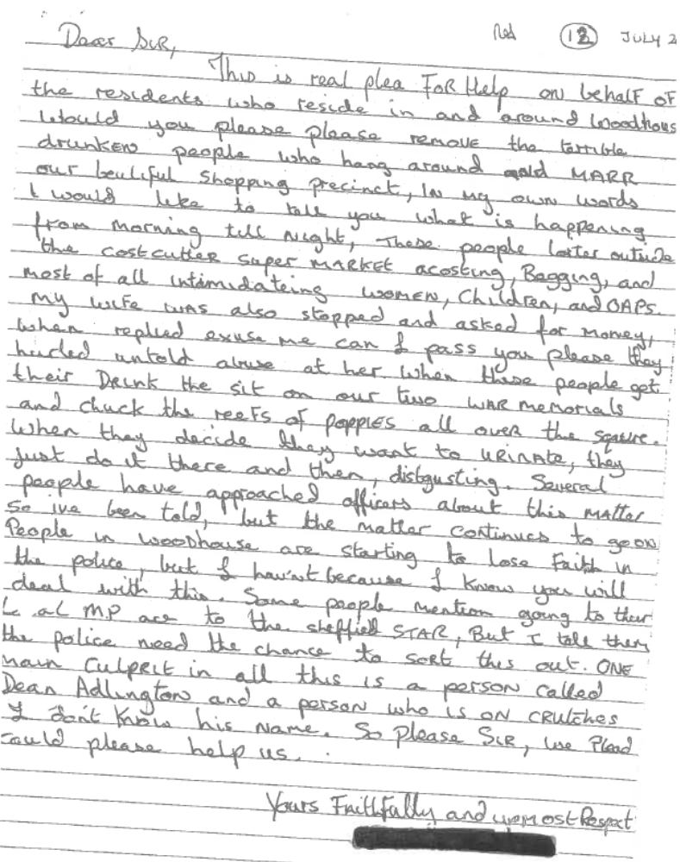
Appendix_2: Public consultation questionnaire and results
Questionnaire Analysis for the Proposed DPPO in Woodhouse
The attached questionnaire was designed in conjunction with PS Fitzgibbons and Sheffield City Council, South East Assembly Officer, Mick Fellowes. An accompanying delivery structure was also developed and delivered by the Woodhouse SNT and the South East Community Assembly. The questionnaire was conducted in the week commencing 13th of September 2010 in and around the Woodhouse village area. In the week the consultation included speaking to the public, businesses, young people, VCF groups and St Anne’s Hostel. The questionnaire that was used is attached below with the analysis following,
Questionnaire
What is your post code?
Are you: male  female 
Age: Under 16  16-24  25-34  35-49  50-59  60+ 
1) Have you seen any alcohol related anti social behaviour in Woodhouse village in the past 12 months? (Please tick)
❒ Yes  No
If you answered yes, where did it happen? (Please tick all that apply)
❒ Outside your business/ your home
❒ Outside a business / shop
❒ In a public area (please specify) …………………………………………………….
❒ Within a licensed premises / licensed area
❒ Another location (please specify) ……………………………………………………
❒ Within your neighbourhood
2) What type of anti social behaviour was it?
❒ Vandalism  Graffiti  Harassment  Intimidation
❒ Noise  Urination  Verbal Abuse  Litter
❒ Begging  Other (Please specify)
……………………………………………………………………………………………………………………………………………………………………………
3) How would you characterise the individuals or groups who take part in this behaviour?
(Please include approximate ages)…………………………………………………………………………………………………………
4) Do you support the proposal for a Designated Public Place Order (DPPO) in Woodhouse Village centre?
❒ Yes  No

Appendix_3: Public consultation questionnaire and results – 6 Month Review
Please help us to tackle alcohol related crime and disorder in Woodhouse centre.
A Designated Public Place Order (DPPO) has been in place in the centre of Woodhouse since April 2011. Designated Public Place Orders (DPPO’s), allow police or authorised officers to confiscate alcohol in public places, or require a person to stop drinking. Failure to comply can result in arrest and/or a fine. DPPO’s are implemented by local councils in order to address alcohol-related crime and disorder in public places. We are seeking the opinions of the local community as to how effective you think this DPPO has been.
Questionnaire
What is your post code?
Are you: male  female 
Age: Under 16  16-24  25-34  35-49  50-59  60+ 
1) Are you aware that the DPPO has been in place since April?
❒ Yes  No
2) Have you noticed a reduction in street drinking and ASB (Anti Social Behaviour) in Woodhouse village this summer (post April)?
❒ Yes  No
3) What type of anti social behaviour was it?
❒ Vandalism  Graffiti  Harassment  Intimidation
❒ Noise  Urination  Verbal Abuse  Litter
❒ Begging  Other (Please specify)
……………………………………………………………………………………………………………………………………………………………………………
4) How would you characterise the individuals or groups who take part in this behaviour?
(Please include approximate ages)
…………………………………………………………………………………………………………
5) Do you support the continuation of the Designated Public Place Order (DPPO) in Woodhouse Village centre?
❒ Yes  No
If you answered no, please give your reasons below:
……………………………………………………………………………………………………………………………………………………………………………

Appendix_4: Business consultation questionnaire and results
Thirty-two Businesses located within the DPPO area, asked the following questions:

Questionnaire

1) Would you support the continuation of the DPPO?
❒ Yes  No
2) Have you noticed / experienced a difference in issues relating to street drinking or anti-social behaviour within Woodhouse Village over the past year?
❒ Yes  No
3) Do you think the DPPO has improved trading in Woodhouse for your business?
❒ Yes  No
All 32 consulted stated they would support the continuation of the DPPO, 27 of those stated a notable difference in street drinking/associated ASB and 14 have experienced an improvement in trading since the DPPO came into force.
Worthy of note is that two new businesses have established since commencement of the DPPO and continue to trade successfully.
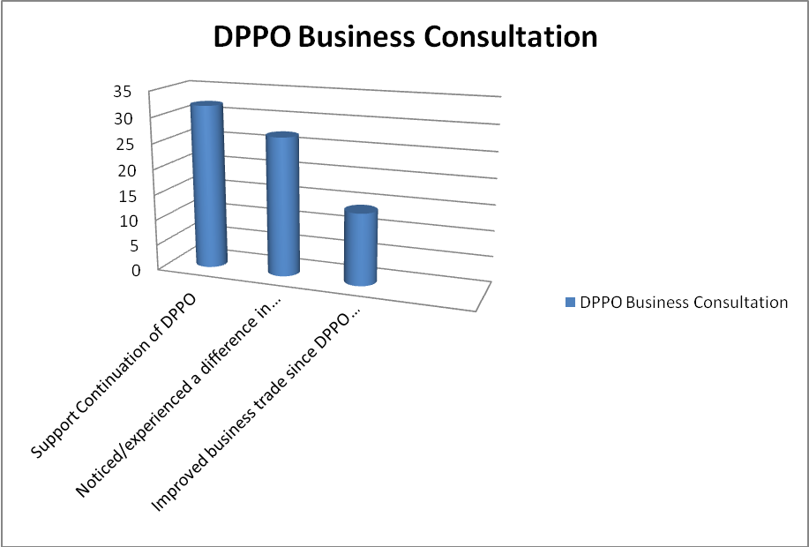
Supporting Evidence

Scanning
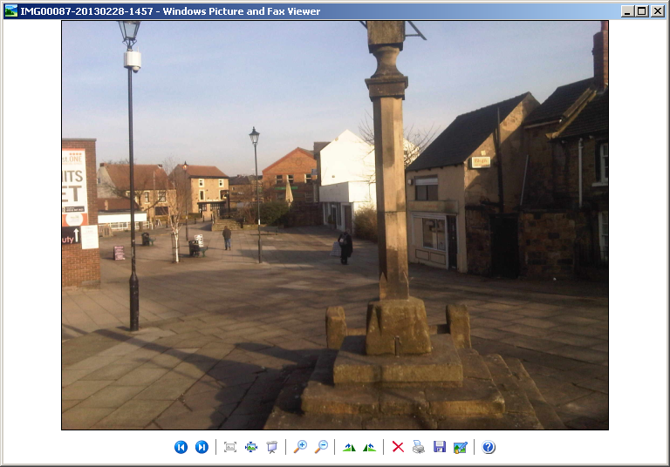
Market Square, Woodhouse (MOCAM visible on the lamppost to the left.)
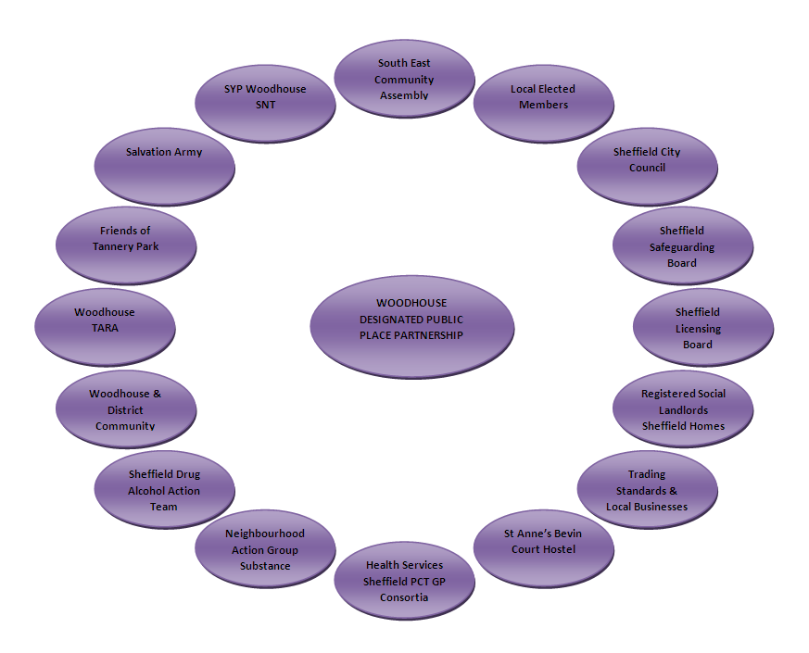

Stakeholders involved at the Scanning Stage of the Project

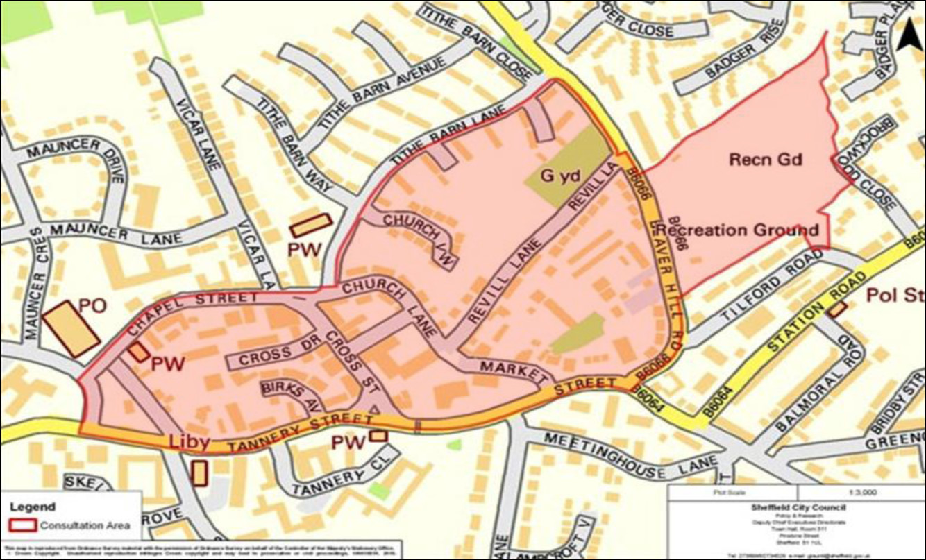
Analysis
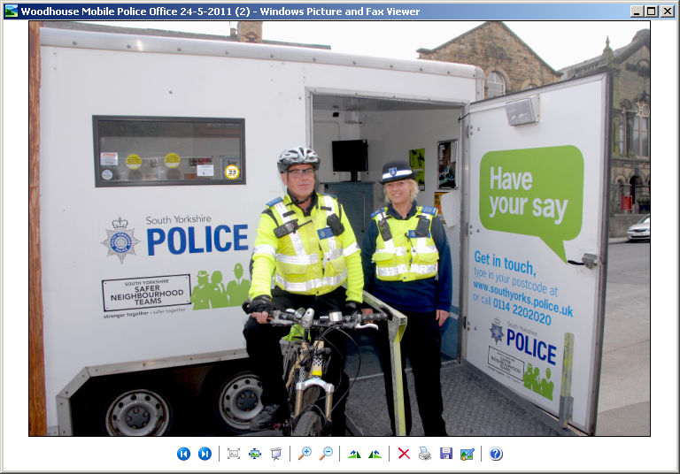
Public Consultation event Woodhouse 2010

The map below shows the area of concern within Woodhouse, as identified through local intelligence and consultation, ASB incidents and key locations 2007-10.
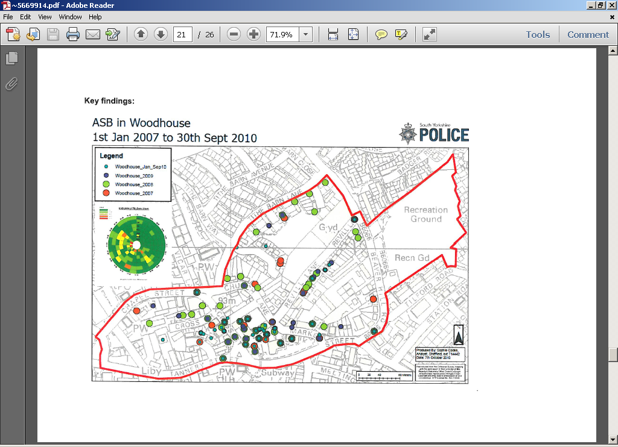

Table 1: ASB Annual Data 2007 – 2010 (Defined area as per Map above)
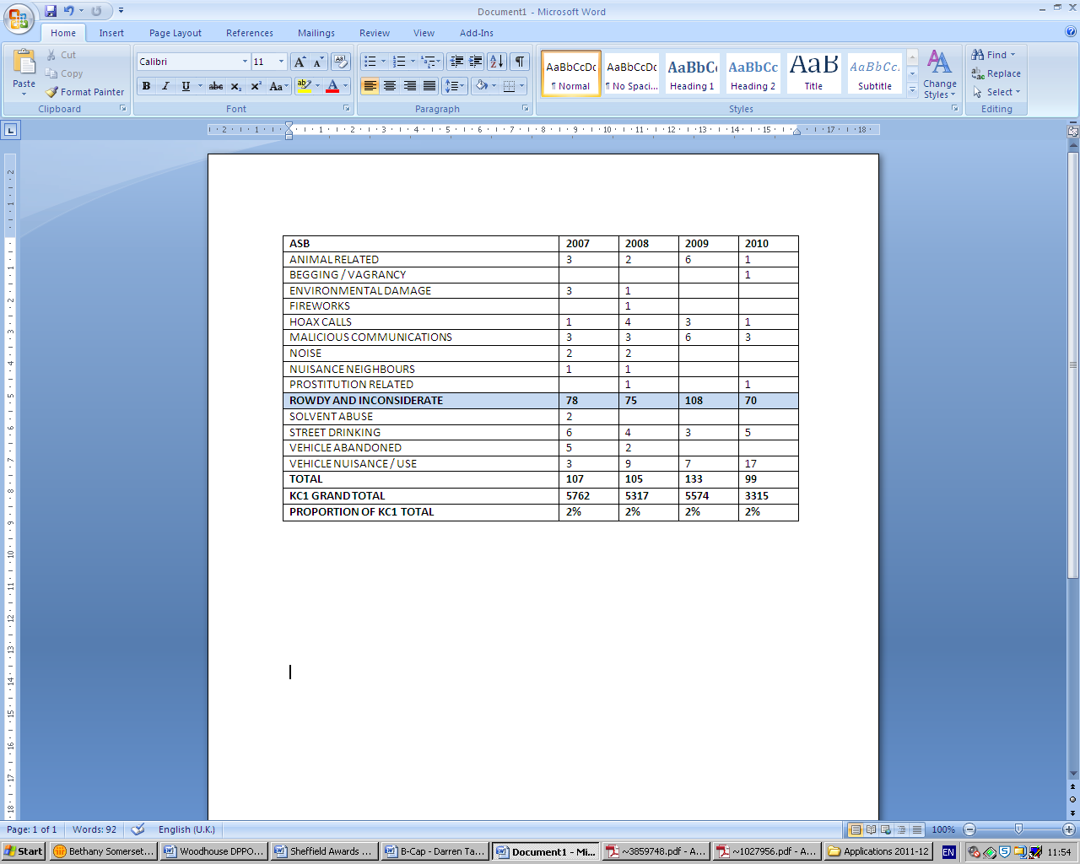
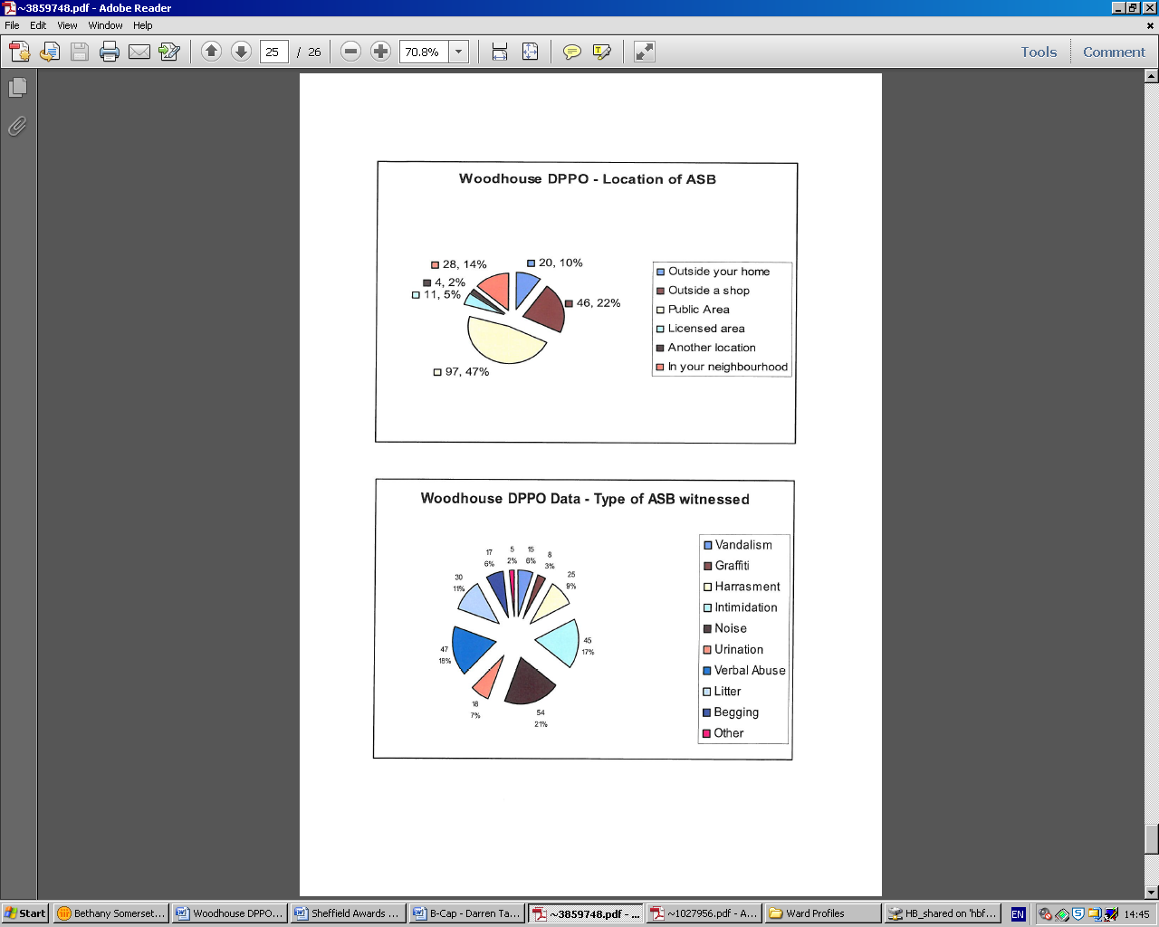
Response
Leaflet for those found to be in Breach of the DPPO
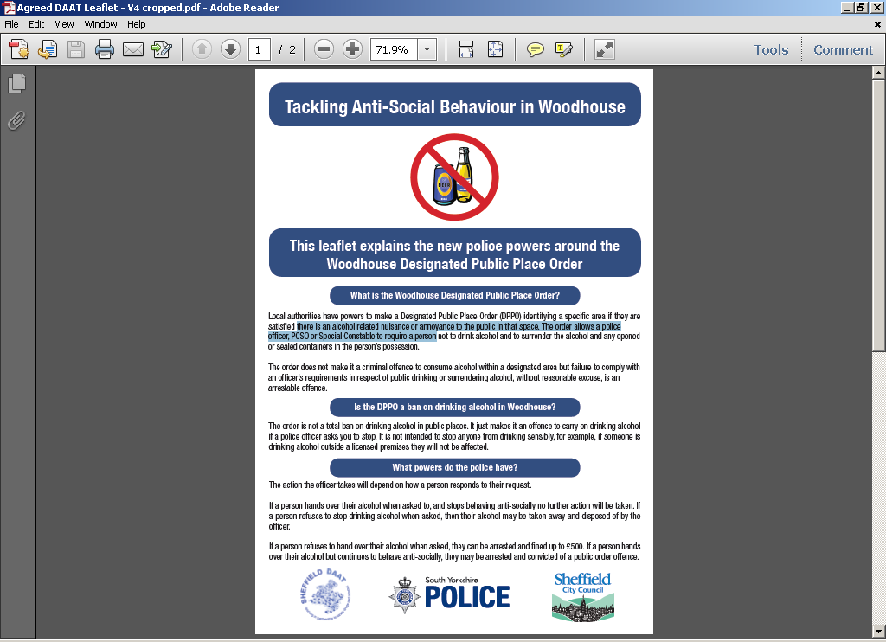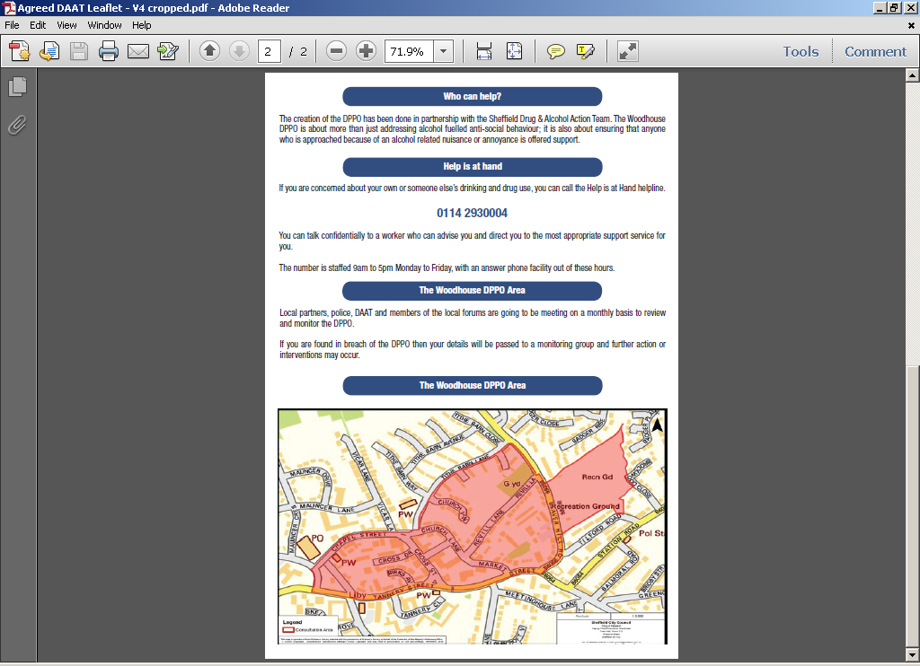
SEAP Local Service Flyer
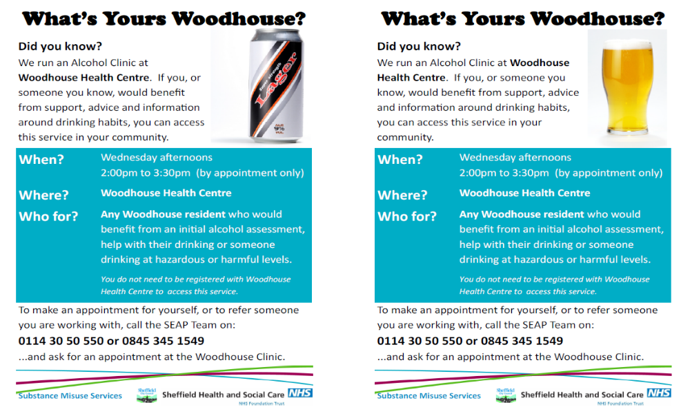
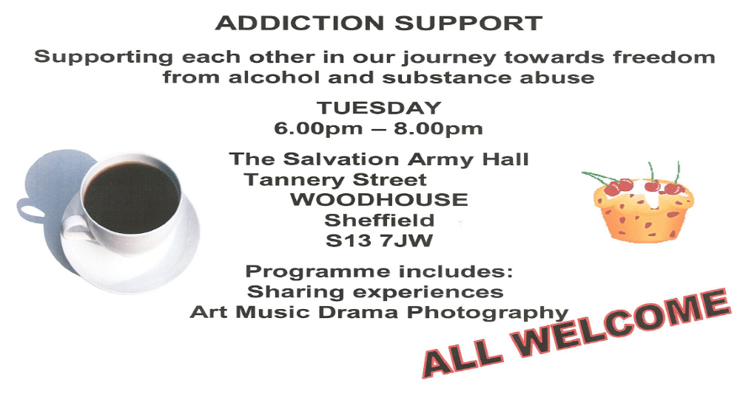
Salvation Army ‘Addiction Support’ Flyer
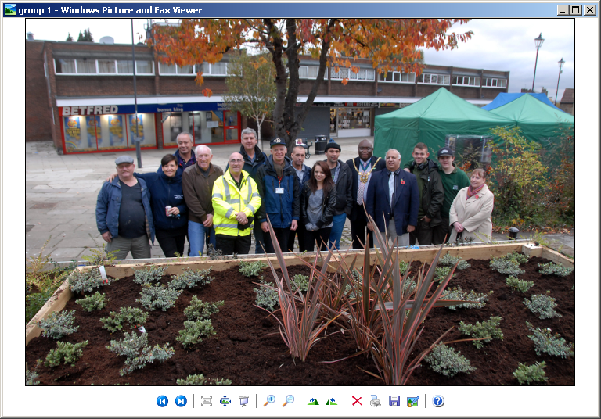
Local partners and residents unveil the newly developed square “Planter Project”
Assessment
The graph below indicates the spread of incidents recorded over the last 12 months and during September 2012:
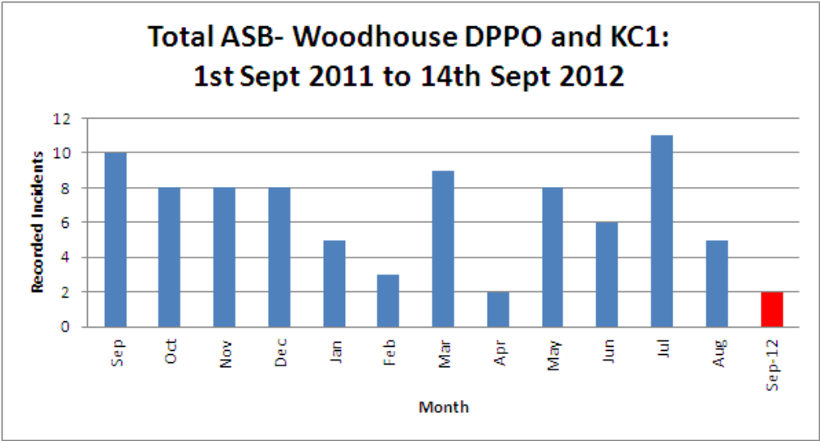
Throughout the period, ASB within the DPPO area has accounted for between 1-8% of that recorded within the KC1 SNT as a whole (demonstrated in table below)
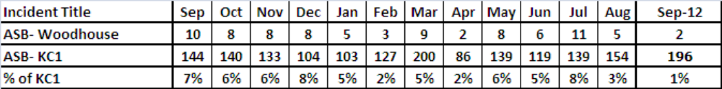
A reduction in total ASB recording year on year, with a 45% reduction between the 2008-2009 period and that for 2011-12 .
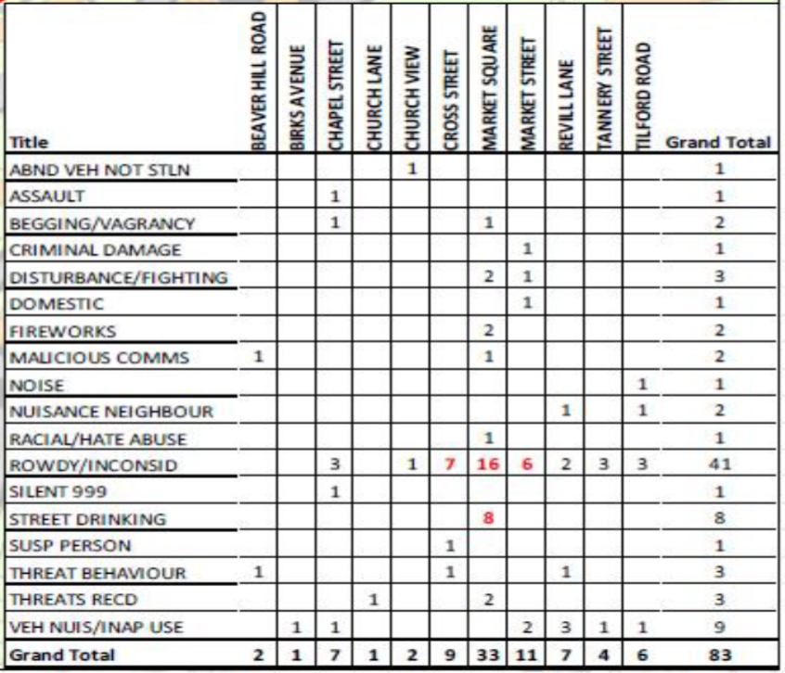

DPPO area, key incidents remain rowdy/inconsiderate behaviour and street drinking, however this may be a direct result of continuing public confidence to report such as a result of the extensive media coverage and information via social media e.g. Twitter.
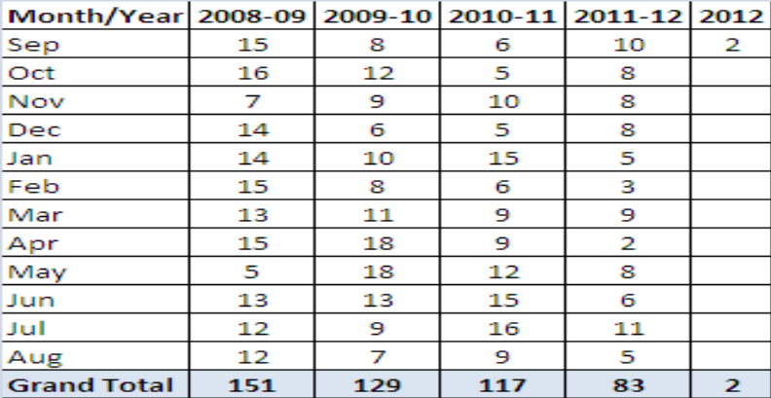
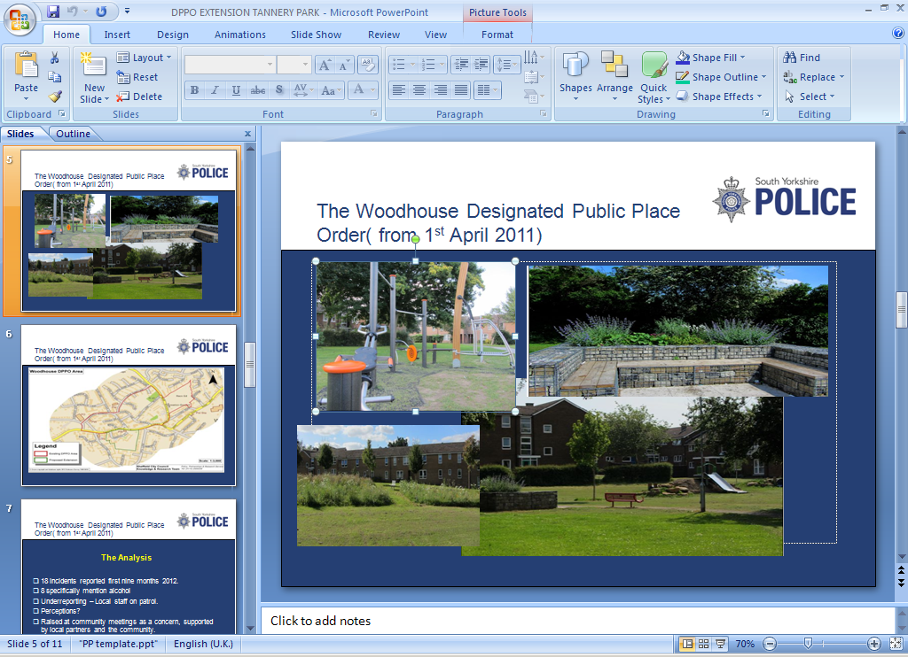
Views of Tannery Park, Sheffield
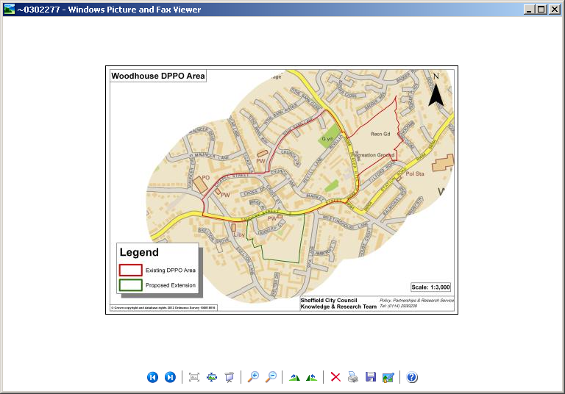
Expansion of the original DPPO




